Stephen

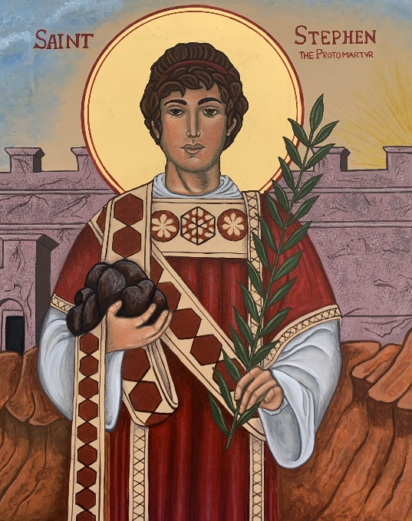
When the council members heard Stephen's speech, they were angry and furious. But Stephen was filled with the Holy Spirit. He looked toward heaven, where he saw our glorious God and Jesus standing at his right side. Then Stephen said, "I see heaven open and the Son of Man standing at the right side of God!" The council members shouted and covered their ears. At once they all attacked Stephen and dragged him out of the city. Then they started throwing stones at him. The men who had brought charges against him put their coats at the feet of a young man named Saul. As Stephen was being stoned to death, he called out, "Lord Jesus, please welcome me!" He knelt down and shouted, "Lord, don't blame them for what they have done." Then he died.
Acts 7: 54-60
Background
The apostles were very busy in the early Christian church. Acts 6 describes how they were overworked and needed help. They called seven Greek-speaking followers of Jesus to help with the care and feeding of widows and orphans. The Greek word for “serving others” used in this story is “diakonein” from which we get the word “deacon.” They were called “to wait on tables.” This is the same type of humble service that Jesus once provided for his disciples. Jesus cleansed the disciples’ feet before feeding their bodies and souls

These servants of Christ were commissioned in a special ceremony that included “laying on of hands.” This was the same temple ritual used for the sacrifice of sacred animals. In the Old Testament, lives were taken away. In the New Testament, lives were given away. These servants offered themselves as “living sacrifices” to God.

It’s important to note that there was greater emphasis on their duties than any official title. These new servants of the Lord were called to distribute food to orphans and widows. This is the same type of humble service that Jesus shared with his disciples. Jesus cleansed the feet of others and then fed their bodies and souls.

Stephen is described as being “full of grace and power, he did great wonders and signs among the people” (Acts 6:8). He served food, but he also nourished people’s spirits.

Stephen spoke out regularly, telling others about the salvation of our Lord Jesus Christ. His work was so successful that leaders in the temple began to plot against him. With false witnesses they fabricated charges and brought him to trial. They accused Stephen of “sinning against” (1) Moses, (2) the Temple, and (3) the Torah (first five books of the Old Testament). Technically, none of these were really illegal.

Stephen didn’t waste time refuting their petty charges. He seized the opportunity to share the world’s greatest truth. Stephen’s dramatic speech is the longest recorded in the book of Acts. He quoted from the Old Testament twenty-two times explaining God’s message is never limited to one person, place, or book. He made several charges of his own:
- The religious leaders were “stiff-necked” when they ignored God’s special messengers. They were more interested in worshiping “things” like the Temple and Torah. At Mount Sinai, the people rejected Moses and the Commandments by worshipping a golden calf.
- Some people in Israel considered themselves saved because of their nationality. God’s salvation is not limited to any specific nation. God’s saving grace is universal.
- Israel had a history of mistreating God’s messengers. The people had ignored or persecuted all the prophets. Even the sons of Jacob (Israel) sold their brother Joseph into slavery (Genesis 37).

Stephen called his accusers “betrayers and murderers” of “God’s Righteous One” (Acts 7:52). He asserted they were the real lawbreakers. The truth hurt. They cried out with a loud voice and angrily rushed upon him. They dragged him from the city of Jerusalem and stoned him (because their laws forbade killing anyone within the city walls). Ironically, they honored a minor regulation as they broke the commandment against killing.

Stephen knelt and cried out in a loud voice, “Lord, do not hold this sin against them” (Acts 7:60). Stephen had a forgiving spirit like Jesus upon the cross. He was transfigured before his accusers. They “saw his face was like that of an angel.” In this moment of genuine worship, Stephen saw the glory of God. This was a moment of holy “epiphany” (God revealed). While they were stoning him, Stephen prayed, “Lord Jesus, receive my spirit”, and then he died. In a similar manner, Jesus had said, “It is finished. Then he bowed his head and gave up his spirit” (John 19:30).

Reflections
St Francis of Assisi wrote: "Keep a clear eye toward life's end. Do not forget your purpose and destiny as God's creature... Remember that when you leave this earth, you can take with you nothing that you have received--fading symbols of honor, trappings of power--but only what you have given: a full heart enriched by honest service, love, sacrifice and courage” (Letters to Rulers of People, c.1220).

Stephen, the first martyr, was simply a church volunteer. Anyone can make a big difference in God’s kingdom. Stephen did not have years of training but he used his gifts to make an important difference in the church. Church tradition states that he still wearing his serving apron when he died.

Saul of Tarsus was present at the stoning. Coats were laid at his feet. This reveals he was in charge (Acts 7:58). St Augustine said, “'If Stephen had not prayed (and was stoned to death for it), the Church would not have gained Paul.” Saul must have been moved by the power of Stephen’s faith.

Stephen became one of the most popular saints during the Middle Ages. His festival follows immediately after Christmas Day. It marks the beginning of Epiphany, the season we celebrate seeking and finding the light of Christ in the world.

After Stephen’s death, the great persecution of Christians began. The strength and importance of the church in Jerusalem would gradually diminish as Christians were sent to share the Good News with all nations.

The name Stephen (or Stephanie) is Greek for “crown.” These crowns were the special wreaths placed on the heads of the Olympic winners. Saint Stephen forever wears the great crown of glory in God’s kingdom. Stephen shares eternally in the victory that Christ won for us all.

Two thousand years ago the temple authorities sought to silent Stephen and other Christians with the barbaric custom of stoning. They were wrong. Today we see that Stephen based his faith on a firm foundation: the Rock of Ages.

Strength Finders talent: Command
https://www.gallup.com/topic/command_theme.aspx

Command is a very rare gift. This talent enables empowerment. Command is not being bossy all the time. A person with command can speak in a powerful way. Think of command performance. This is an influencing domain strength; so people listen. This talent enables us to see the big picture and often challenges us in meaningful ways.
Stephen spoke with great truth as he confronted the very leaders who had plotted against Jesus. No one spoke against these powerful people but Stephen did. He had courage.
Individuals with this strength are also open to a challenge. The speak truth to power. The best groups look for ways to leverage this talent. It is one of the rarest on the planet. Stephen may have been great at his day job serving others, but he truly accelerated when he spoke and was willing to challenge corrupt leaders.
Note that Stephen with compassion to those who hurt him. The Greek philosopher Antisthenes (studied with Socrates) said “There are only two people who can tell you the truth about yourself an enemy who has lost their temper and a friend who loves you dearly.”

Enneagram connections: Eight
https://cpenneagram.com/enneagram-type-eight
Eights are willing to take on a challenge. They are willing to speak truth to power. They are particularly vocal when an injustice has been done. This type speaks with fearlessness, power, and strength.
Some eights derive their strength from times of feeling weakness. Stephen and the other followers of Jesus must have felt helpless when he was crucified. This was an unsettled matter that must be avenged. Stephen found his revenge in love and forgiveness.
It has been suggested that the word enemy is a Roman word that was twisted from its original meaning. It is the combination of the words Enne and Amicus. This would be a nine friend. The Roman adaptation of The Odyssey was called The Aeneid where the theme is power over the empowerment we find in the Enneagram. People who empowered other, spoke the truth, and was able to rebel against tyranny would have been enemies to Roman dictatorship and abuse.
I suspect Stephen was a social eight. He cared for others. He forgave those who tortured him. Stephen’s sacrifice was an epiphany because he forgave with true love and showed all the light and power of God’s love and forgiveness.

But was I the first martyr, who
Gave up no more than life, while you.
Already free among the dead.
Your rags stripped off, your fetters shed,
Surrendered what all other men
Irrevocably keep, and when
Your battered ship at anchor lay

Seemingly safe in that dark bay
No ripple stirs, obediently
Put out a second time to sea
Well knowing that your death (in vain
Died once) must all be died again?

C.S. Lewis

Questions
1. Hymnist Horatio Bolton Nelson, Lord Admiral Nelson’s grandnephew, understood conflict and wrestled with the meaning of personal sacrifice. What sacrifices do modern Christians make?
- From all Thy saints in warfare, for all Thy saints at rest,
To Thee, O blessèd Jesus, all praises be addressed;
Thou, Lord, didst win the battle, that they might conquerors be;
Their crowns of living glory are lit with rays from Thee.
- Praise for the first of martyrs, who saw Thee ready stand
To aid in midst of torments, to plead at God’s right hand.
Share we with him, if summoned by death our Lord to own,
On earth the faithful witness, in heaven the martyr’s crown. (1864)

2. What does it mean to be a servant church? How are you a servant in Christ’s name? What sacrifices are you willing to make?

3. Stephen worshiped God with all his body, mind, and heart. How does our worship impact all that we say and do?

