Nicodemus

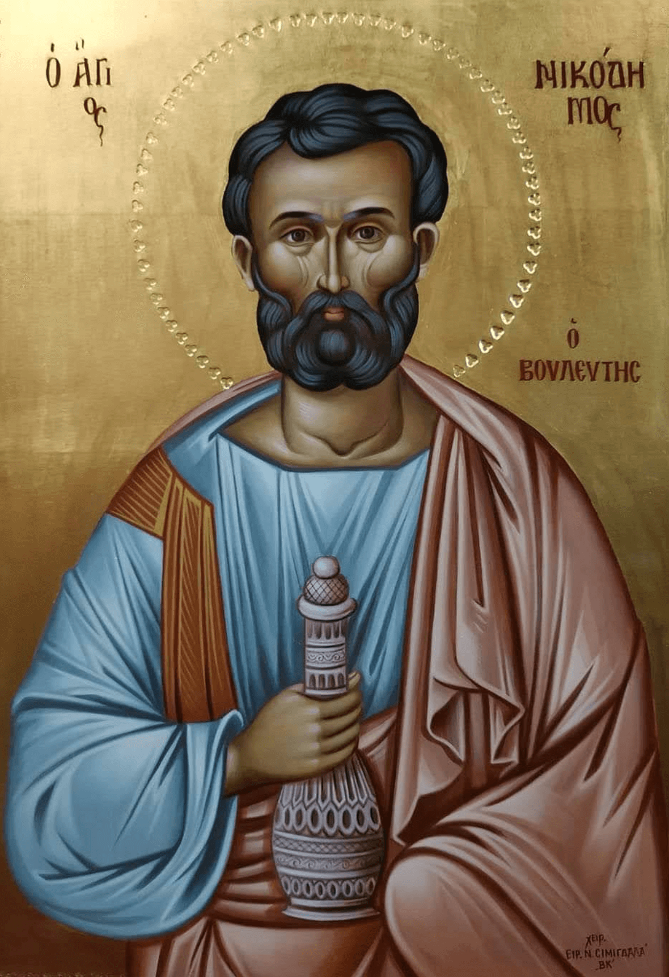
“There was a man named Nicodemus who was a Pharisee and a Jewish leader. One night he went to Jesus and said, "Sir, we know that God has sent you to teach us. You could not work these miracles, unless God were with you."
Jesus replied, "I tell you for certain that you must be born from above before you can see God's kingdom!"
Nicodemus asked, "How can a grown man ever be born a second time?" Jesus answered:
I tell you for certain that before you can get into God's kingdom, you must be born not only by water, but by the Spirit. Humans give life to their children. Yet only God's Spirit can change you into a child of God. Don't be surprised when I say that you must be born from above. Only God's Spirit gives new life. The Spirit is like the wind that blows wherever it wants to. You can hear the wind, but you don't know where it comes from or where it is going.” John 3: 1-8

Background
Nicodemus was a Pharisee and a very influential man. There were only a few thousand Pharisees in Israel, yet they controlled much of the power and wealth. He probably came from a very distinguished Jewish family. In 63 BC, a man named Nicodemus was ambassador to Pompey, the Emperor of Rome. Years later during the fall of Jerusalem, the son of a man named Nicodemus negotiated the surrender of the city. This was a family of movers and shakers who operated behind the scenes.

Nicodemus was probably a member of the Sanhedrin. This was like a supreme court of seventy members. It was like being a senator, judge, and archbishop all rolled into one. They had religious jurisdiction over every Jew in the world. It was their responsibility to deal with anyone suspected of being a false prophet.

Nicodemus came to Jesus at night. Why? Rabbis declared that the best time to study was at night when a person would not be disturbed (Jesus would have been surrounded by crowds during the day). Nicodemus may also have been a very cautious man and not ready to meet with Jesus in public. Nicodemus may have been on just a fact-finding journey. Whatever the reason, Jesus graciously welcomed him.

Nicodemus immediately treated Jesus with great respect by calling him “rabbi”. He was like a new “disciple” with many questions. A sign of great wisdom is realizing how much we don’t know and a willingness to learn more.

Jesus confirmed that he was truly God’s messenger. He stated that a person must be “born again” or better yet, “born from above” in order to be a part of God’s kingdom. Here, Jesus used the Greek word “anothen” which has three possible meanings:
- It can mean a radical change in life, like the birth of a child.
- It can mean “again,” like a second birth.
- Finally, it can mean a “spiritual” or “heavenly” birth. This can only be accomplished with God’s divine intervention into our lives.

Nicodemus was confused. He understood the (second) literal meaning of the word, a second birth. He realized it was impossible to reenter the womb!

Jesus’ response reveals that this change in our lives happens through the power of God’s spirit. This is God’s gift of baptism. We can never accomplish any real change on our own; this change is a gift of God’s love and grace.

Nicodemus' final question indicated he was still in the dark. Jesus' response could be translated as, "Hey, you’re supposed to be the teacher, and yet I'm the one teaching you!”

Jesus responds with what Martin Luther called "the Gospel in miniature”: “For God so loved the world that he gave his only Son, so that everyone who believes in him may not perish but may have eternal life” (John 3:16).

God sent Jesus into the world so that we can have new life from faith. “Everlasting life” is just not the promise of fellowship with God in the hereafter. It is also an abundant and meaningful life we can immediately realize. This salvation can happen now!

We see a spiritual journey unfold in Nicodemus’ life. He began his journey “at night” with the first hesitant steps to find answers. Later he cautiously defended Jesus before the Sanhedrin saying, “Does our law not judge people without first giving them a hearing?” (John 7: 51). Finally, Nicodemus joined Joseph from Arimathea (also in the Sanhedrin) to publicly care for the body of Jesus after the crucifixion (John 19: 39-42). Early church tradition maintains that Nicodemus continued to grow in his faith and remained a faithful follower of Christ.

Reflections
The early church refers to baptism as a “sacrament.” This is a Latin word meaning “gift from God.” Baptism is a new birth. Paul spoke of a person dying with Christ and then rising to a new life (Romans 6: 1-11). In baptism we drown to worldly ways and then God’s Spirit breathes new life into us. We are born from above. Paul speaks of new converts as babies in Christ (1 Corinthians 3: 1-2). In Christ we are a new creation (Galatians 6:15).
- Baptism is God’s cleansing. We realize that we not saved by our own efforts. We humbly recognize that we need God to wash away our sin (1 Peter 3: 21-22, Acts 22: 16). This is like the story of Noah’s ark. The waters cleansed the earth but the faithful were saved from chaos and death (1 Peter 3: 18-22).
- We are baptized into the family of God. We are adopted into the fellowship of believers (Ephesians 1:3-5, Galatians 3:25-29). We belong to God’s family (II Corinthians 5: 17). This relationship is sealed by the power of the Holy Spirit (Ephesians 1: 13-14, II Corinthians 1: 21-22).

Baptism is best described as a way of life. This is not just a one-time event, but also a great gift that must be celebrated and appreciated every day of our lives. Living in our baptism we find a new purpose for all that we do (Ephesians 5: 14).

The name “Nicodemus” means “victor over the people.” Nicodemus was certainly an influential person when he came to visit Jesus. That night he began a spiritual journey. Nicodemus graciously helped minister to the crucified Christ. On Easter Sunday he discovered that Jesus was the real victor. By his death Jesus defeated the power of death. Christ is the ultimate Victor!

For God The greatest one
So loved The greatest degree
The world The greatest amount of people
That He gave The greatest generosity
His only begotten Son The greatest present
That whosoever The greatest invitation
Believes in Him The greatest salvation
Should not The greatest certainty
Perish The greatest loss
But The greatest difference
Have The greatest possession
Eternal The greatest length
Life The greatest gift ⁽¹⁾
John 3: 16

Strength Finders talent: Input
https://www.gallup.com/cliftonstrengths/en/252278/input-theme.aspx

Folks with the gift of input are very good at acquiring information, ideas, or even building contact relationships. They are very inquisitive. It is obvious that Nicodemus came from a family that nourished this strength. The world of learning new things or important new encounters with important people would have been exciting because of its ability to provide variety and interesting complexity.

Initially Nicodemus was able to provide relevant and tangible help to the religious and political leaders of his time. His encounter with Jesus changed everything. Nicodemus moved to dedicate himself to work of God’s kingdom.

Enneagram connections: Six
https://cpenneagram.com/enneagram-type-six
Sixes can often be found in hierarchical organizations. Nicodemus would have done well as a leader of the Sanhedrin. As an ambassador, he would have been very skilled at problem solving. He must have had his doubts when he met with Jesus. Who was this person outside of the usual power structures? Did he present a threat to the established order? Could potential conflict be avoided?
His conversations with Jesus at first caused confusion. A low level six turns to fight, flight, or freeze in difficult situations. Jesus spoke to his body (9) and heart (3) as well as his mind (6) “For God so loved the world…. He gave his only begotten son…”. Jesus helped him step into a world beyond fear and anxiety. Nicodemus fears gave way to trust in God.
Nicodemus was empowered to speak out on Jesus’ behalf during the trial. Normally a low level six would have not spoken out. Nicodemus must have been filled with holy courage. Later he helped with Christ’s burial. Once again, a healthy six working to care for and protect others. Nicodemus had learned not to trust human institutions but to trust in the work of God’s Kingdom.
Later he became an important leader in the early church. His meeting in the dark of night led to finding and sharing the light of the world…
“I will give you as a light to the nations, that my salvation may reach to the end of the earth.”^{7”}Thus says the Lord, the Redeemer of Israel and his Holy One, to one deeply despised, abhorred by the nations, the slave of rulers, “Kings shall see and stand up, princes, and they shall prostrate themselves, because of the Lord, who is faithful, the Holy One of Israel, who has chosen you.” ⁸Thus says the Lord: In a time of favor I have answered you, on a day of salvation I have helped you; I have kept you and given you as a covenant to the people, to establish the land, to apportion the desolate heritages; ⁹saying to the prisoners, “Come out,” to those who are in darkness, “Show yourselves.” They shall feed along the ways, on all the bare heights shall be their pasture; ¹⁰they shall not hunger or thirst, neither scorching wind nor sun shall strike them down, for he who has pity on them will lead them, and by springs of water will guide them. Isaiah 49

Nicodemus at Night
NICODEMUS.
The streets are silent. The dark houses seem
Like sepulchres, in which the sleepers lie
Wrapped in their shrouds, and for the moment dead.
The lamps are all extinguished; only one
Burns steadily, and from the door its light
Lies like a shining gate across the street.
He waits for me. Ah, should this be at last
The long-expected Christ! I see him there
Sitting alone, deep-buried in his thought,
As if the weight of all the world were resting
Upon him, and thus bowed him down. O Rabbi,
We know thou art a Teacher come from God,
For no man can perform the miracles
Thou dost perform, except the Lord be with him.
Thou art a Prophet, sent here to proclaim
The Kingdom of the Lord. Behold in me
A Ruler of the Jews, who long have waited
The coming of that kingdom. Tell me of it.
CHRISTUS.
Verily, verily I say unto thee,
Except a man be born again, he cannot
Behold the Kingdom of God!
NICODEMUS.
Be born again?
How can a man be born when he is old?
Say, can he enter for a second time
Into his mother's womb, and so be born?
CHRISTUS.
Verily I say unto thee, except
A man be born of water and the spirit,
He cannot enter into the Kingdom of God.
For that which of the flesh is born, is flesh;
And that which of the spirit is born, is spirit.

CHRISTUS: A MYSTERY, Henry Wadsworth Longfellow, 1872

Questions
- Susan Helen Peterson dedicated her life sharing Christ’s salvation with others. Her final hymn speaks of being “born anew.” What does this mean to you? What difference does it make in a persons life?
A man named Nicodemus to Jesus came one night.
He said, “We know you’ve come from God; your wonders show his might.”
In answer, Jesus did declare, “Give heed, these words are true:
You cannot see God’s kingdom come unless you’re born anew.” (1999, public domain)

- What does your baptism mean to you? Can baptism really change a person? Describe a “baptismal way of life.”

- In what ways can you available to those seeking answers? Do you place limits on your availability? Who have you helped?

1 Our Value To God by Maurice McCarthy

