### **Mary, John Mark’s mother**

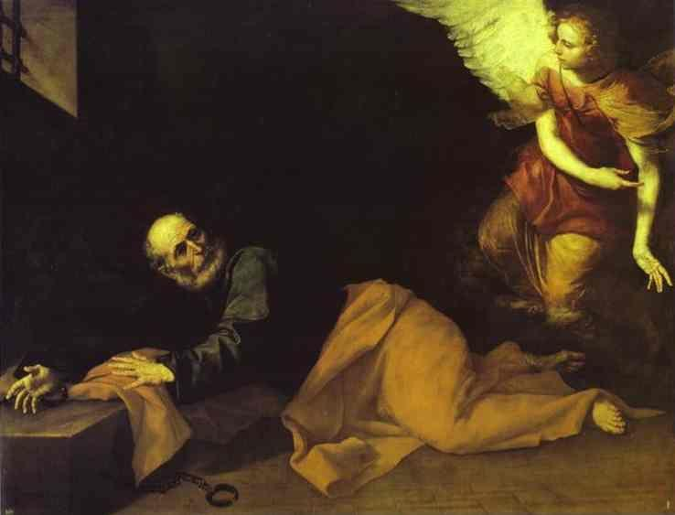 *The night before Peter was to be put on trial, he was asleep and bound by two chains. A soldier was guarding him on each side, and two other soldiers were guarding the entrance to the jail. Suddenly an angel from the Lord appeared, and light flashed around in the cell. The angel poked Peter in the side and woke him up. Then he said, "Quick! Get up!"*

*The chains fell off his hands, and the angel said, "Get dressed and put on your sandals." Peter did what he was told. Then the angel said, "Now put on your coat and follow me." Peter left with the angel, but he thought everything was only a dream. They went past the two groups of soldiers, and when they came to the iron gate to the city, it opened by itself. They went out and were going along the street, when all at once the angel disappeared.*

*Peter now realized what had happened, and he said, "I am certain that the Lord sent his angel to rescue me from Herod and from everything the Jewish leaders planned to do to me." Then Peter went to the house of Mary the mother of John whose other name was Mark. Many of the Lord's followers had come together there and were praying.*

*Peter knocked on the gate, and a servant named Rhoda came to answer. When she heard Peter's voice, she was too excited to open the gate. She ran back into the house and said that Peter was standing there.*

*"You are crazy!" everyone told her. But she kept saying that it was Peter. Then they said, "It must be his angel." But Peter kept on knocking, until finally they opened the gate. They saw him and were completely amazed. Peter motioned for them to keep quiet. Then he told how the Lord had led him out of jail. He also said, "Tell James and the others what has happened." After that, he left and went somewhere else. The next morning the soldiers who had been on guard were terribly worried and wondered what had happened to Peter. Herod ordered his own soldiers to search for him, but they could not find him. Then he questioned the guards and had them put to death. After this, Herod left Judea to stay in Caesarea for a while.*  Acts 12: 6-19

## Background

This Mary is mentioned only once in Scripture. Peter was arrested and imprisoned by Herod Agrippa and was awaiting trial and probable execution in Jerusalem. Members of the early church gathered in prayer for his release. An angel interceded and Peter was released from captivity. Later that night, Peter headed for Mary’s house to inform others of his escape.

A young servant named Rhoda answered the door. She was so surprised that she left the poor guy standing outside while she ran to tell the others. First Peter was locked up and then he was locked out! The disciples inside didn’t believe Rhoda. Despite their prayers, they could not imagine this miracle had truly happened. Peter kept knocking at the door until they finally let him in (not exactly hospitality at its best!).

Mary’s house was large enough to accommodate a large gathering of Christians for prayer and worship. She would have been a woman of some wealth to afford such a large home and maintain a domestic servant. She may have been a widow but her husband’s name is never mentioned.

We do know that Mary was the mother of John Mark, who later would write the Gospel of Mark. John Mark was just a young man while Jesus ministered in Jerusalem. Mark probably grew up hearing the teachings of Jesus and watching the activities of the early church. Mary’s close relative, Barnabas, would later take John Mark on a missionary journey with Paul. Mary provided the early church with a place to meet and they in turn helped her son mature into a champion of the faith.

Mixed traditions indicate that Mary’s house may have been “The Cenacle” or center of many activities in the early church. They suggest that her home was the location of the upper room where Jesus gathered with his disciples to share the Last Supper. They identify her home as the place the disciples gathered on Easter morning, site of the great Pentecost event, and many other gatherings of the early church. We simply do not know if all these connections are accurate.

We do know that Mary modeled Christian hospitality in the early church. Jesus relied on hospitality throughout his life and ministry. It began with the innkeeper who provided the manger in a rustic shelter. It included those who supplied food and shelter during his journeys, the home of Mary and Martha, a banquet by Matthew, the room for the Last Supper, and even the tomb in which his body was laid. Men and women alike provided a special place for Jesus.

## Reflections

The early Christians would gather in homes for fellowship, worship, and discipleship. “They devoted themselves to the apostles’ teaching and fellowship, to the breaking of bread and the prayers” (Acts 2: 42).

These Christians would share food with each other in what was called it an “Agape meal.” Agape is a unique word that means “God’s love.” This is the type of love we can never accomplish on our own. Agape is the type of love that is inspired and enabled by God. Agape means the hand of God reaches down and gives us a heavenly assist. God’s love raises us up to share a special fellowship beyond our human limitations.

The early Christians demonstrated this type of love when they gathered together. Many new converts were attracted to the church because of the genuine care and compassion they witnessed. These Christians modeled their lives by the example set by Jesus. Characteristics of biblical fellowship include:

1. Sharing our true feelings (**authenticity**). Romans 12:9

2. Encouraging each other (**mutuality**). Galatians 5: 22-26

3. Supporting each other (**sympathy**). Galatians 6: 1-2

4. Forgiving each other (**mercy**). Ephesians 4: 31-32

5. Speaking truth in love (**honesty**). Ephesians 4:15

6. Admitting our weaknesses (**humility**). Romans 12:16

7. Respecting our differences (**courtesy**). Romans 12:10

1. Allowing no gossiping (**confidentiality**). Ephesians 4: 31-32
2. Making the group a priority (**frequency**). Colossians 3: 16-17
3. Sharing God’s good news with each other (**faith**). Ephesians 5: 19-20

Mary was a gentlewoman. “Gentlemen” and “Gentlewomen” are old English words, which originally meant those who practiced Christian hospitality. A gentleperson was an individual who considers other people’s needs first. Gentle people openly shared the love of Christ.

Later the word deteriorated to mean those who had fame, fortune, or possessions. The world is filled with people who pride themselves on their independence, self-sufficiency, and ignore the needs of others. Christians are called to rise above self-centered concerns. Christ taught that the most important things in life are shared with others. We only need the love of Christ in our hearts to be God’s gentleperson.

Mary’s gentility enabled the struggling early church to have a special place for fellowship. I like to think that Mary’s home had a plaque at the front door which read “As for me and my household, we will serve the LORD” (Joshua 24:15).

## Questions

## 1. Father Frederick Faber began many communities of faith helping the lost and poor. He once converted a tavern into a place of holy sanctuary. How do his verses describe God’s love?

## There’s a wideness in God’s mercy, Like the wideness of the sea;

## There’s a kindness in His justice, which is more than liberty.

## There is welcome for the sinner, and more graces for the good;

## There is mercy with the Savior; There is healing in His blood.

## There is grace enough for thousands. Of new worlds as great as this;

## There is room for fresh creations, in that upper home of bliss. (1854)

2. In which ways do you (or your church) demonstrate biblical fellowship? Authenticity? Mutuality? Sympathy? Mercy? Honesty? Humility? Courtesy? Confidentiality? Frequency? Faith?

3. Are you a gentleperson? In what ways?

# **Guest and Host**

*Jesus was forever changing places.*

*Guest or host he managed both superlatively.*

*He needed people as much as they needed him*

*And did not blush to suffer*

*the risk of being rejected*

*In either role.*

*He entertained as lord or visitor,*

*A generous soul who also reaped the largesse of his company.*

*He found it blessed to receive as well as to give.*

*He did it all with perfect graciousness:*

*The guest and host of our humanity.*

## Pastor Thomas John Carlisle, 1913-1992